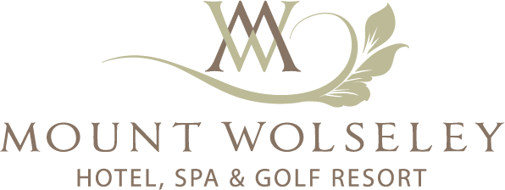

Funeral Menus 2026

Menu A

Roast Supreme of Chicken, Fine Beans, Roast Gravy, Chateau Potato & Seasonal Vegetables
Contains Allergen: Milk, Celery, Sulphites

~ ~ ~

Freshly Brewed Tea & Coffee
€24.50pp

Menu B

Soup of the Day, Warm Bread Rolls
~ ~ ~
Roast Supreme of Chicken, Fine Beans, Roast Gravy, Chateau Potato & Seasonal Vegetables
~ ~ ~
Freshly Brewed Tea & Coffee
Contains Allergen: Gluten (Wheat), Milk, Celery, Sulphites

€28.50pp

Menu C

Soup of the Day, Warm Bread Rolls
~ ~ ~
Slow cooked Irish Short Rib of Beef, Chateau Potato, Roast Gravy
~ ~ ~
Eaton Mess, Strawberries, Dairy Cream, Strawberry Coulis
~ ~ ~
Freshly Brewed Tea & Coffee
Contains Allergen: Gluten (Wheat), Milk, Egg, Celery, Sulphites

€34.50pp

Menu D

Soup of the Day, Warm Bread Rolls
~ ~ ~
Slow cooked Irish Short Rib of Beef, Chateau Potato, Roast Gravy

Or

Baked Salmon En Croute, Savory Rice Filling, Scallions, Chateau Potato, Hollandaise Sauce
~ ~ ~
Baileys Cheesecake, Chocolate Sauce, Cream Chantilly
Contains Allergen: Gluten (Wheat), Milk, Egg, Fish, Celery, Soya, Sulphites
~ ~ ~
Freshly Brewed Tea or Coffee
€40.00pp

